Chapter 1, Problem 9.

The current through an element is shown in Fig. 1.26. Determine the total charge that passed through the element at:
(a) t = 1 s (b) t = 3 s (c) t = 5 s

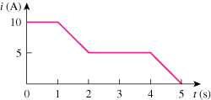

Figure 1.26
For Prob. 1.9.

